- Jonas created a program which initiates multiple modules parallelly unrelated to each other. Martha comes to rescue and optimizes the code, now the program uses the input and generates outputs based on the previous one. Identify the type of cohesion the programmers used?

- The Indian Security Enforcement team is planning to create an application to secure the Prime Minister of Bangladesh on her visit to New Delhi this year. Design a Structure diagram based on the following information.
Secure PM module provides the Initiate flag to Send Armored Convoy module to send armored vehicles to receive the PM from the airport. Secure PM model receives routes from Get Routes library module upon providing the current time of security initiation and then, provides the routes to Secure Routes module to get the security status. For each route, the Secure Routes module provides route data to Block Route and gets route status which is then provided to Set Snipers modules to get sniper status. Set Snipers sends information to the Assign Sniper module if snipers are assigned, otherwise it sends to Alert Sniper module and gets sniper status from both the modules. Subsequently, the route status is provided to Allocate Local Police to get the local security status. Secure PM provides security status to on page connector Hotel Security module if the destination of PM is ITC Maurya Hotel, else to off page connector Alert Special Forces module if destination is conference.

- In order to get feedback from the patients, the hospital named after Pearl City has taken a plan to develop an application software. They have planned to offer two basic options in the software whenever a patient will enter the application, where one is for rating the overall service of the hospital and another one is for reviewing the ratings.
If a patient wants to rate the hospital management system and overall quality he or she needs to fill up a form and after submitting the information required for the form through the help of a button, a patient can compare or relate his or her ratings with others by clicking the another option for reviewing others’ ratings.
So, as mentioned earlier the patient can compare the overall performance of the hospital with respect to other hospitals or he/she can relate the different components of the hospital that is working individually with a proper manner or not by searching specific keywords and selecting the performance type of overall performance with respect to other hospitals or internal performance rated by the other patients.

Now, construct a WND diagram to support the above scenario.

- The Bangladesh government is planning for an E-voting system to cast the votes of every citizen of the country at the exact time with appropriate results. Following is the initial proposal of it.
Every voter first inputs their NID number and Fingerprint into the system. Verify identity process receives this data and compares the NID with existing data from the NID data store. It also extracts the existing fingerprint from the data store and forwards it to compare fingerprint along with new fingerprint (i.e. given by the citizen). The process uses Neural Network technique and sends back the match result. Based on the result, the verify identity process sends Invalid fingerprint messages to the voter. The show candidate process collects the list of all candidates from the candidate data store and sends it to the voter. Voter then chooses his/her favorite candidate and the casting vote process receives it and stores it in the votes. It also sends an acknowledgement to the voter.
Administrators can request total voting information to generate reports. It collects all voting information from the Votes data store, prepares a report and sends it to the administrator. At the end, the admin can declare the election result. There is also the presiding officer who can send start/stop signals to the voting status process. He can also pause the voting system in case of any emergency. Another responsibility of the presiding office is to add new candidates into the system.

a. Design a context diagram based on the above scenario.
b. Design a level 1 diagram using the above scenario. Also identify if there is any error in the diagram.

PROBLEMS WITH SOLUTION

- An e-commerce site allows customers to order products, based on availability.
Customers fill out an online application form containing name, phone number, credit card information, and products they want to purchase, which is then submitted to the e-commerce management system. The system checks that the products are available, and the system verifies that the customer has an authentic credit card and satisfactory past record of purchases. If the products are available and the customer meets the required criteria, the system confirms to the customer that order placement is successful. Otherwise, the customer is informed that order placement failed.
Draw Level-0 and Level-1 Data Flow Diagram (DFD) of the e-commerce management system.

Solution: a. Level-0 Data Flow Diagram (DFD)
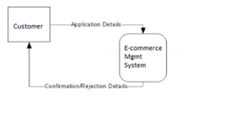

Solution: b. Level-1 Data Flow Diagram (DFD)
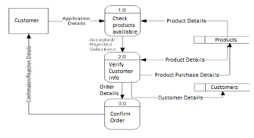

6. What is the Fan-in and Fanout of Process module? Do you think this is acceptable?
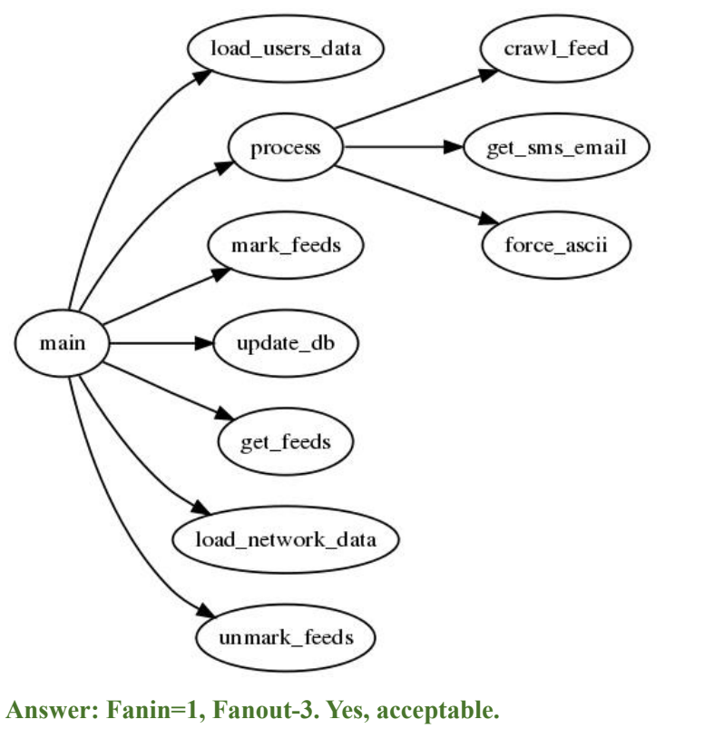

7. Roamer is a watch brand from Switzerland and they want to calculate the total watch revenue of the R Line System Line up. In order to generate the watch revenue, initially the watch records are retrieved for all of the watches in the record file, where the records are also validated. The validated records are then used to calculate the net price. For calculating the net price, the cost price is initially calculated using the watch id, and materials information. From the cost price, tax withheld is calculated using the tax rate for specific watch id and thus the net price of every watch is updated. Furthermore, process sales determines the total price for any watch, according to the order id and watch id. The orders are also verified by their order id and then classified into regular orders or bulk orders. For the regular order, the regular price is calculated and the regular invoice is returned. However for the bulk orders, a discount is retrieved, and then the discounted price is calculated from which the bulk invoice would be sent. Finally, after the total price is collected from the invoice, a checkout is printed of the total price. Draw a structured chart for the mentioned details.
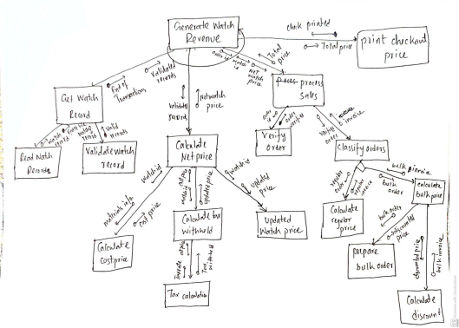
8. BRACU-Scheduler is a program tasked with staff scheduling and weekly roster creation. Create schedule module first receives a task type flag from the Monitor roster module by providing the current roster status information. Based on the flag, Create schedule can either initiate regular scheduling or a CP-solver by taking into account the staff requests. Next, generate a regular schedule module first retrieves the employees on duty for next week from the Fetch employee module. In order to generate this employee list, Fetch employee module uses Get employee module which is a library module and Resolve calendar conflict module in the order they are mentioned and they return employee list and filtered employee list based on vacation notice, respectively. Until the final roster is created for all employees, Generate regular schedule calls upon the Assign Employee module with details of each employee and receives assignment data. It then sends this data to the Update roster module and receives the updated roster. Finally, the finished roster is passed onto the Dispatch roster module which is an on-page connector. On the other hand, Create schedule uses a Initiate CP-solver module to generate schedules with staff requests which is an off-page connector. Design a structure chart based on the above information.

